Love the examples on this Learning Targets wall. The targets are written in student friendly language. This teacher goes above and beyond by describing the purpose and identifying success criteria.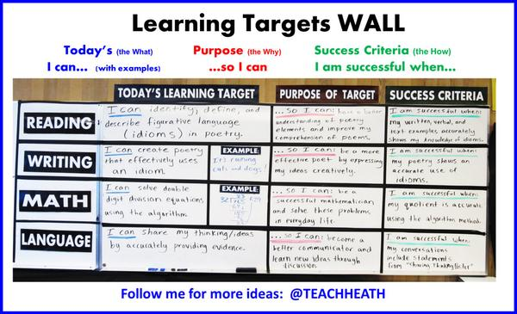

Below is a sub-quality, non-example. Can you tell why?
